常用實驗器材中、英文名稱

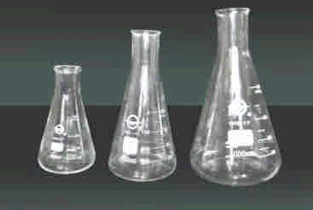 | 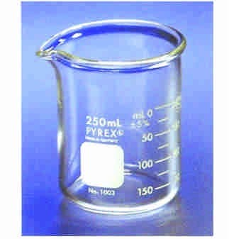 | 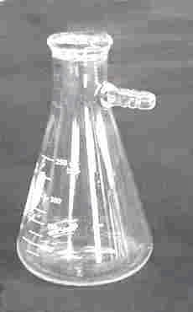
三角燒瓶、錐形瓶  Erlenmeyer flask | 燒杯  Beaker | 抽氣過濾瓶  Filtering flask
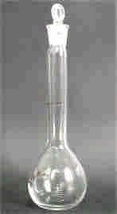 | 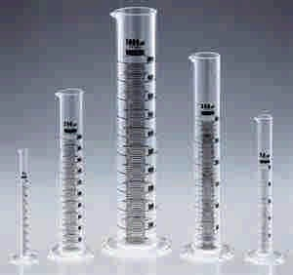 | 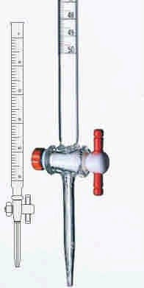
定量瓶、容量瓶  Volumetric flask | 量筒  Graduated cylinder | 滴定管  Buret
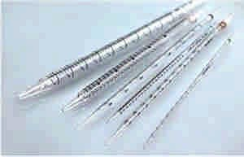 | 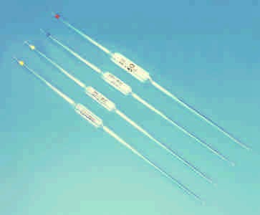 | 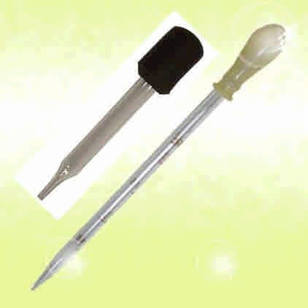
刻度吸量管、分度吸量管  Graduated pipet | 移液吸管  Volumetric pipet | 滴管  Dropper
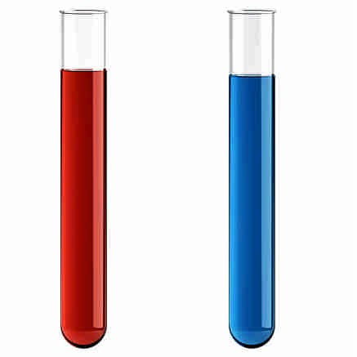 | 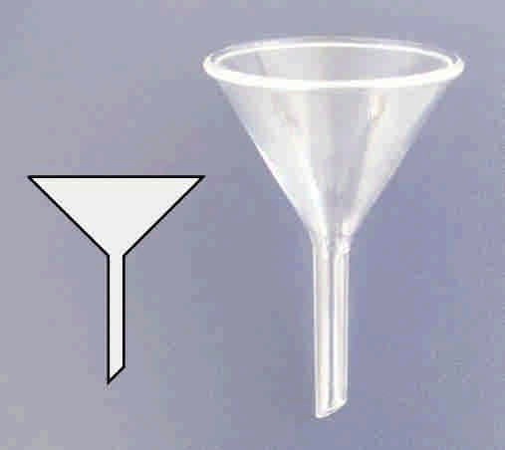 | 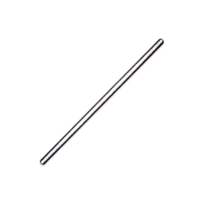
試管  Test tube | 漏斗  Funnel | 攪拌棒  Stirring rod

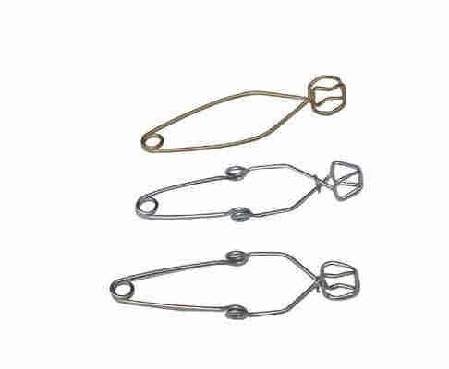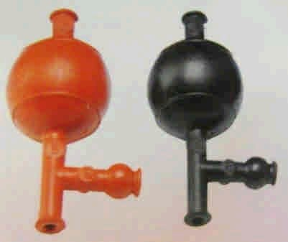

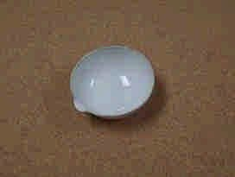 | 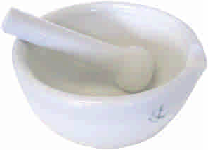 | 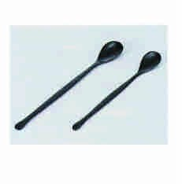
蒸發皿  Evaporating dish | 研缽及杵  Mortar and pestle | 藥杓  Spatula
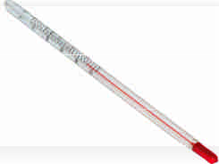 | 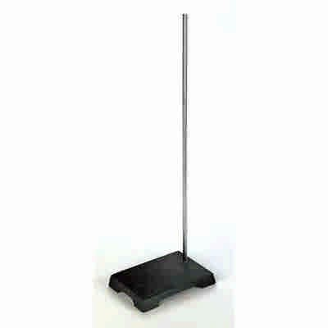 | 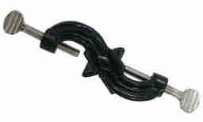
温度計  Thermometer | 鐵架  Ring stand | 直交夾  Right angle clamp
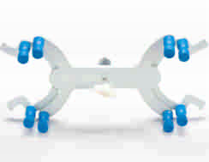 |  | 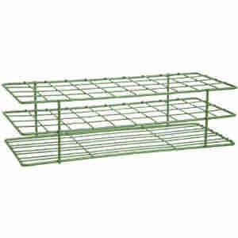
滴定管夾  Buret clamp | 試管夾  Test tube holder | 試管架  Test tube rack
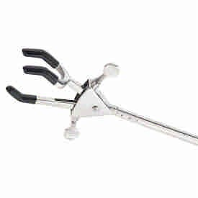 | 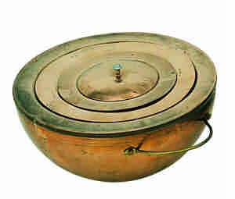
廣用夾、三叉夾  Three prong clamp | 水浴鍋  Water bath pot | 安全吸球  Pipet filler

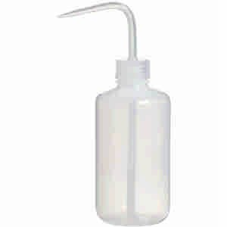 | 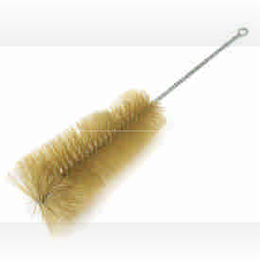 | 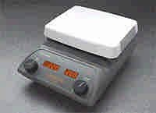
洗瓶  Wash bottle | 試管刷  Test tube brush | 加熱攪拌器  Hot plate stirrer
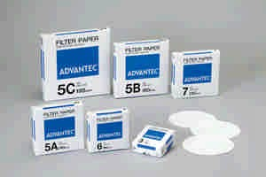 | 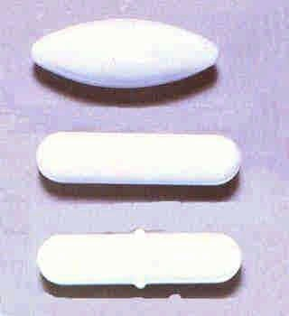
濾紙  Filter paper | 磁石  Stir bar

