2022.7.12

2023 September Entry for International Degree Students

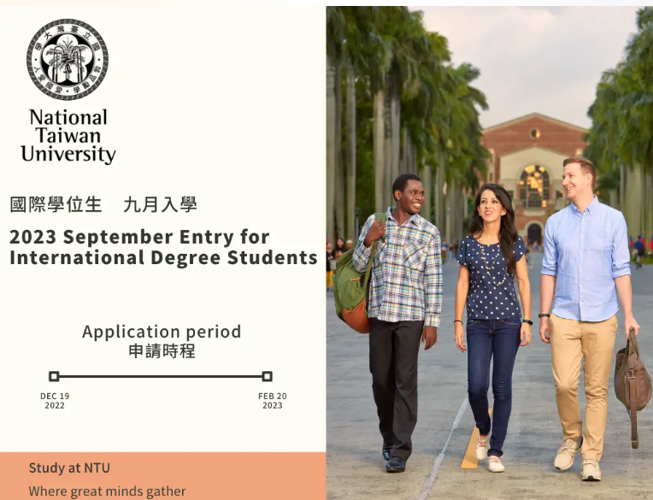

Come study at NTU, where great minds gather!
Thousands of international students studied at NTU for degree, exchange/visiting, and language programs each year.
Would you like to learn Mandarin while pursuing a degree? With abundant resources as well as an open and free academic environment, NTU allows you to create a fruitful study journey! With convenient transportations, various kinds of cuisines, and diverse cultures amid a Mandarin heritage, Taiwan will be your best destination to study abroad!
2023 September Entry Applications for international students are now open.
The application timeline for the 2023 September entry is from December 19, 2022 11AM to February 20, 2023 4PM (GMT+8).
For further information, please refer to our admissions page. If you have any questions, feel free to reach out to us at intadmission@ntu.edu.tw.

