2024.1.26

Final Call for Applications-2024 September Entry 2nd round ends on February 19, 2024 4 PM (GMT+8) !
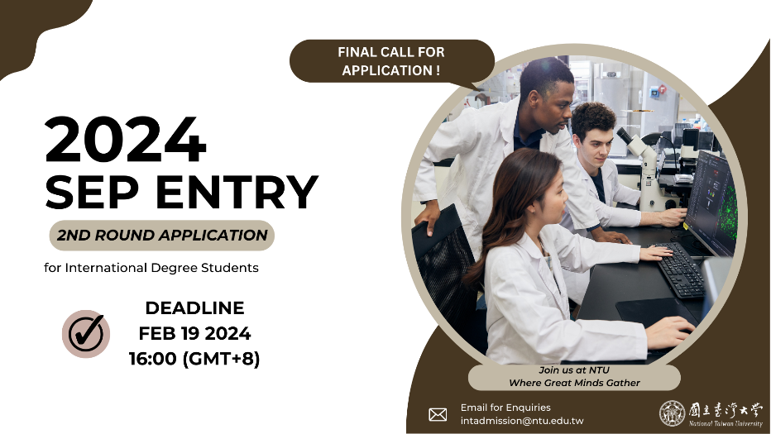
Explore a world-class education at NTU, where thousands of international students embark on transformative journeys through degree programs, exchange/visiting opportunities, and language programs each year.
Immerse yourself in Mandarin while pursuing your degree. NTU provides abundant resources and a free academic environment, allowing you to craft a rewarding study journey.
Taipei, with its convenient transportation, diverse cuisines, and a blend of cultures against a Mandarin heritage backdrop, is your perfect destination for a fulfilling study abroad experience!
Seize this chance to become part of NTU’s globally diverse community and elevate your academic experience.
For more information about application, please refer to this page.
If you have any questions, feel free to reach out to us at intadmission@ntu.edu.tw.



